Banco de dados do site

1. 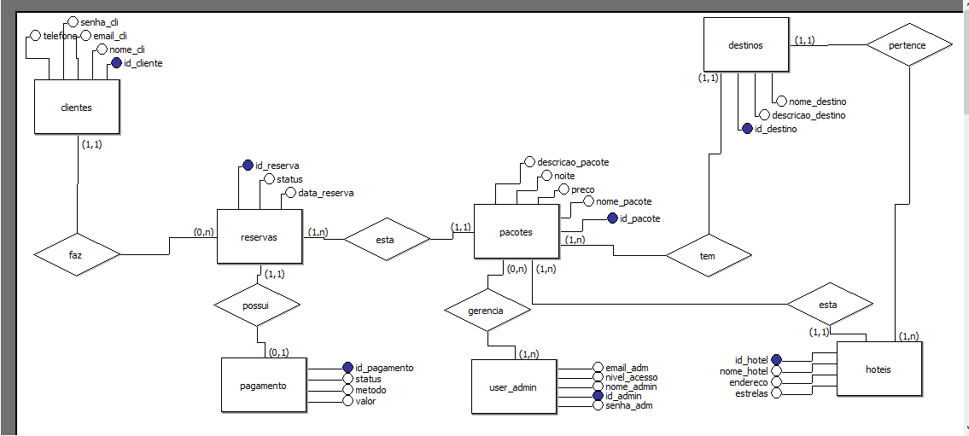Modelo conceitual

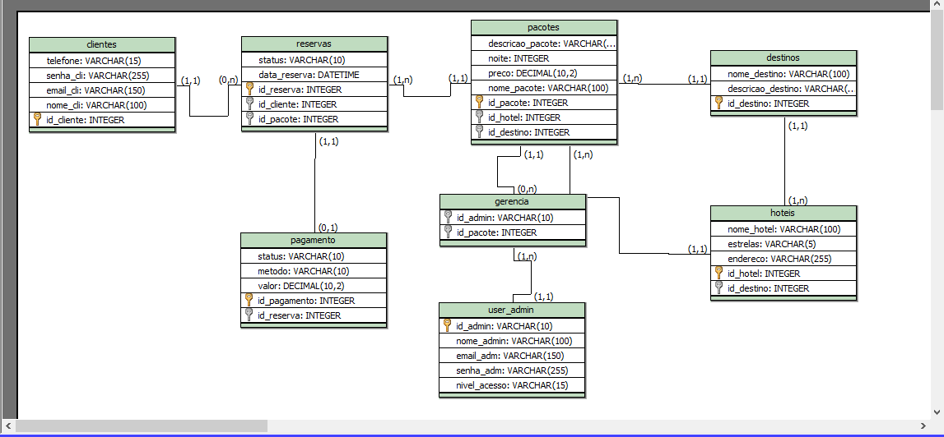2-Modelo logico

3-Script  
*-- Geração de Modelo físico*

*-- Sql ANSI 2003 - brModelo.*

**CREATE TABLE pacotes (**

**descricao_pacote VARCHAR(255),**

**noite INTEGER,**

**preco DECIMAL(10,2),**

**nome_pacote VARCHAR(100),**

**id_pacote INTEGER PRIMARY KEY,**

**id_hotel INTEGER,**

**id_destino INTEGER**

**)**

**CREATE TABLE destinos (**

**nome_destino VARCHAR(100),**

**descricao_destino VARCHAR(255),**

**id_destino INTEGER PRIMARY KEY**

**)**

**CREATE TABLE hoteis (**

**nome_hotel VARCHAR(100),**

**estrelas VARCHAR(5),**

**endereco VARCHAR(255),**

**id_hotel INTEGER PRIMARY KEY,**

**id_destino INTEGER,**

**FOREIGN KEY(id_destino) REFERENCES destinos (id_destino)**

**)**

**CREATE TABLE reservas (**

**status VARCHAR(10),**

**data_reserva DATETIME,**

**id_reserva INTEGER PRIMARY KEY,**

**id_cliente INTEGER,**

**id_pacote INTEGER,**

**FOREIGN KEY(id_pacote) REFERENCES pacotes (id_pacote)**

**)**

**CREATE TABLE clientes (**

**telefone VARCHAR(15),**

**senha_cli VARCHAR(255),**

**email_cli VARCHAR(150),**

**nome_cli VARCHAR(100),**

**id_cliente INTEGER PRIMARY KEY**

**)**

**CREATE TABLE pagamento (**

**status VARCHAR(10),**

**metodo VARCHAR(10),**

**valor DECIMAL(10,2),**

**id_pagamento INTEGER PRIMARY KEY,**

**id_reserva INTEGER,**

**FOREIGN KEY(id_reserva) REFERENCES reservas (id_reserva)**

**)**

**CREATE TABLE gerencia (**

**id_admin VARCHAR(10),**

**id_pacote INTEGER,**

**FOREIGN KEY(id_pacote) REFERENCES pacotes (id_pacote)**

**)**

**CREATE TABLE user_admin (**

**id_admin VARCHAR(10) PRIMARY KEY,**

**nome_admin VARCHAR(100),**

**email_adm VARCHAR(150),**

**senha_adm VARCHAR(255),**

**nivel_acesso VARCHAR(15)**

**)**

**ALTER TABLE pacotes ADD FOREIGN KEY(id_hotel) REFERENCES hoteis (id_hotel)**

**ALTER TABLE pacotes ADD FOREIGN KEY(id_destino) REFERENCES destinos (id_destino)**

**ALTER TABLE reservas ADD FOREIGN KEY(id_cliente) REFERENCES clientes (id_cliente)**

**ALTER TABLE gerencia ADD FOREIGN KEY(id_admin) REFERENCES user_admin (id_admin)**